

Report Cockpit 5.7.0.0

Document History

|  |  |  |  |
| --- | --- | --- | --- |
| Version | Updated By | Date | Comments |
| 0.1 | Kinnari Pandam | 15-01-2016 | Initial Draft |
|  |  |  |  |
|  |  |  |  |

Document Sign-Off

|  |  |  |
| --- | --- | --- |
| Name | Role | Signature/Date |
| Gyaneshwar Dubey |  |  |
|  |  |  |
|  |  |  |

Table of Contents

1. Introduction 3

1.1 Purpose 3

1.2 Intended Audience 3

1.3 Document Scope 3

1.4 Assumptions/Restrictions 3

1.5 Documents Structure 3

2. Configuration & Report Creation 4

2.1 Configuration steps for the Report Cockpit 4

2.2 Report Creation steps 4

2.3 Download Reports 17

2.4 Create Custom Reports (Jasper Reports) 17

1. Introduction

Purpose

This document is information on steps to enabled Report Cockpit for your store.

Intended Audience

This document is aimed at Hybris developers and reports analyst members who wants enabled & use report cockpit in hybris.

Document Scope

This document covers the details about the steps.

Assumptions/Restrictions

Hyrbis 5.5 custom code will be migrated to 5.7.0.0 but this doesn’t support data migration. Only functionality will be available in 5.7.0.0

Documents Structure

|  |  |  |
| --- | --- | --- |
| Section | | Description |
| 1 | Introduction | Describes the purpose and intended audience of the document and explains its structure. |
| 2 | Configuration & Report Creation | Steps to install and configure the module. |

1. Configuration & Report Creation

Configuration steps for the Report Cockpit

1. Add following extensions in **config\localextensions.xml** file.

|  |
| --- |
| <extension name=*'reportcockpit'* />  <extension name=*'virtualjdbc'* /> |

1. Go to platform directory in command prompt and run: **ant all**.
2. Start the server: **hybrisserver.bat**
3. Go to browser and hit URL: <http://localhost:9001/reportcockpit/>

Image

1. Login as User Name: **admin** & Password: **nimda**

**Image**

Report Creation steps

Adding a Report Widget to the dashboard:

1. Click the **Create new widget** button.

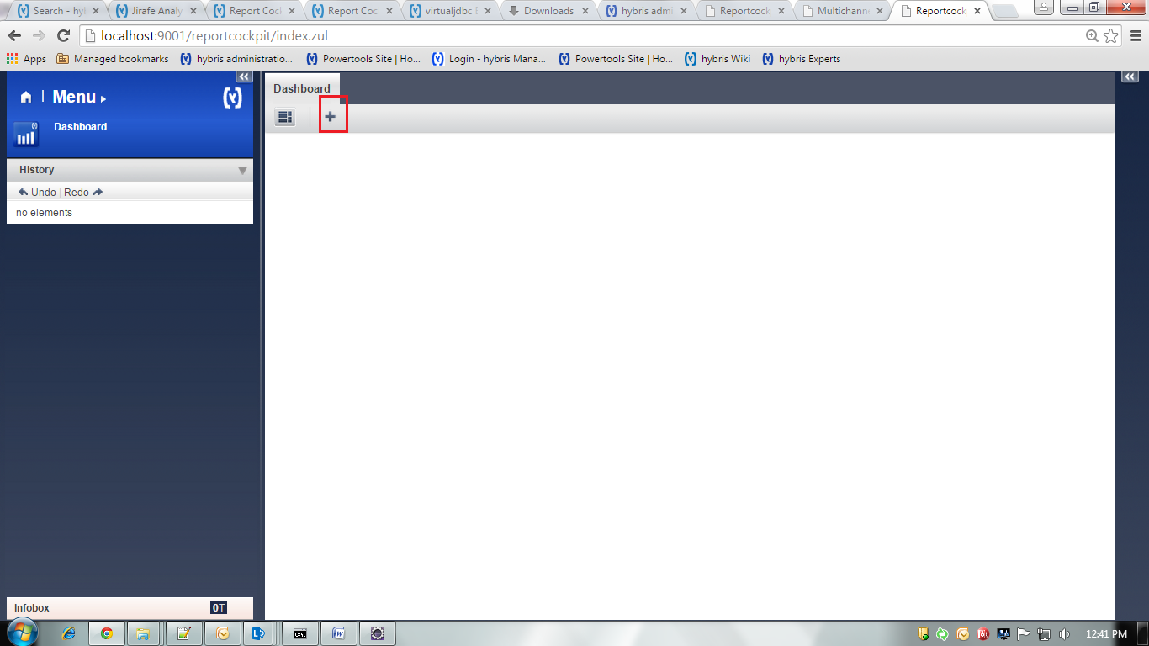

1. Select **Use an existing media**

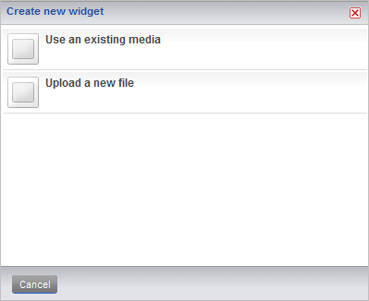

1. The **Create new widget - Choose report** dialog box displays. Select one of the report widgets:

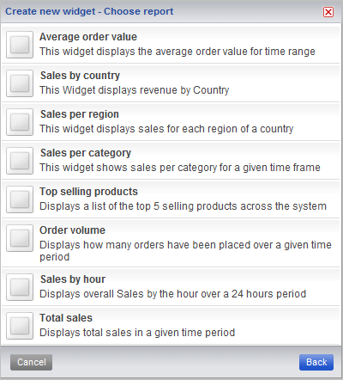

1. The selected report is displayed in the **Dashboard**:

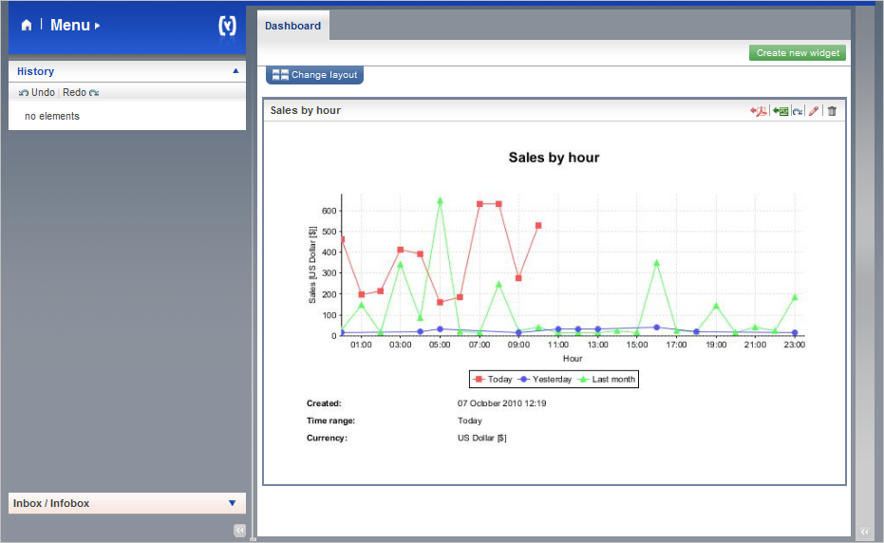

1. You can change layout of dashboard:

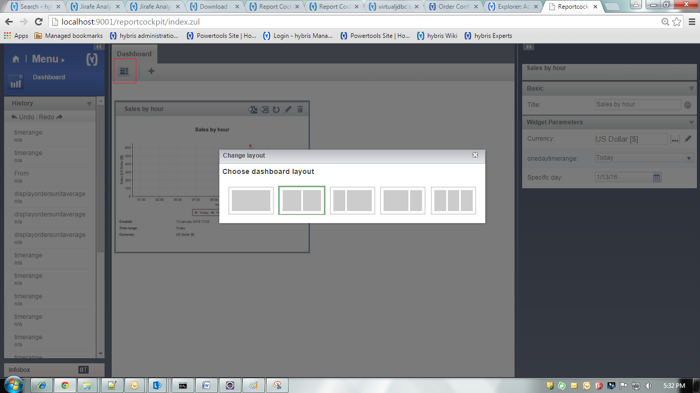

Available Reports in Hybris by default:

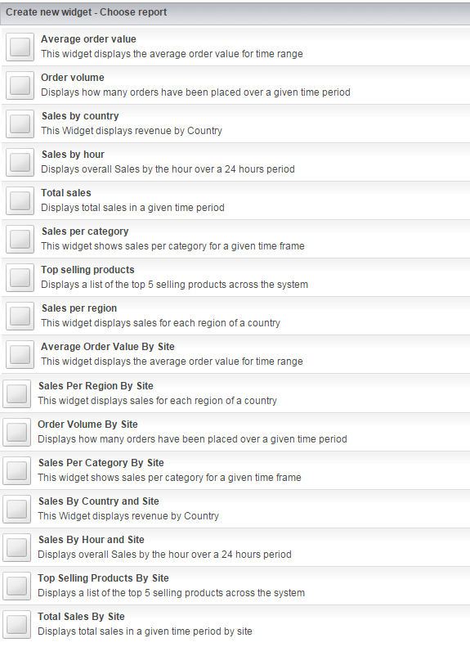

* 1. **Average order value :**

Average order value for time range.

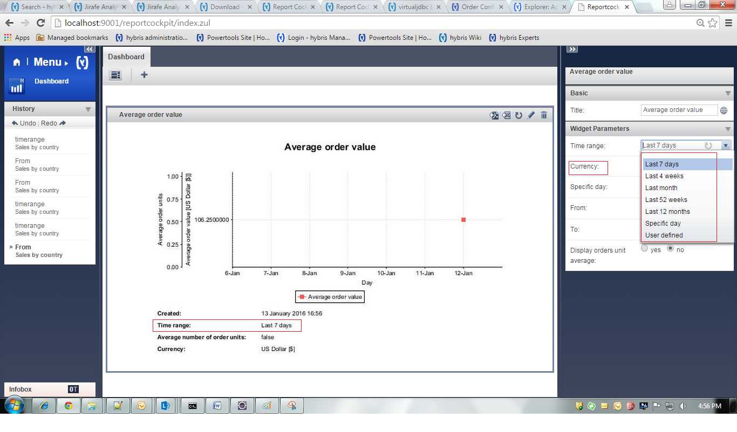

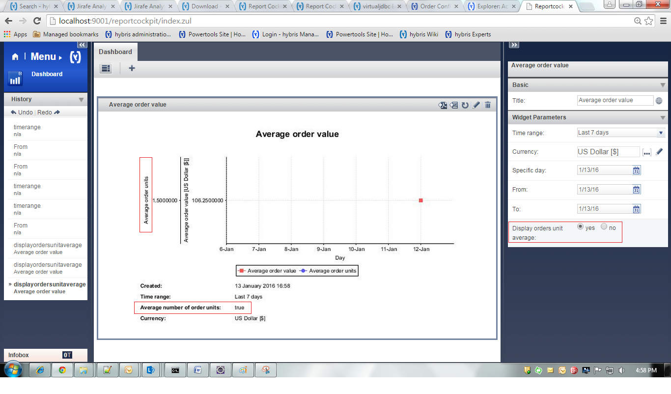

* 1. **Order Volume:**

Displays how many orders have been placed over a given time period

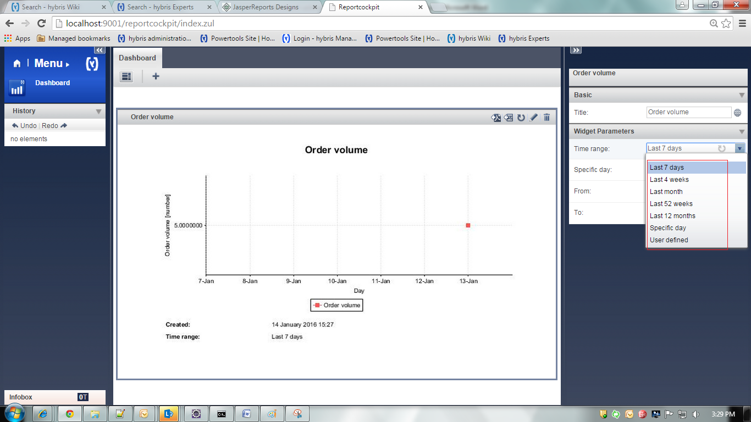

* 1. **Sales by Country:**

Displays revenue by Country.

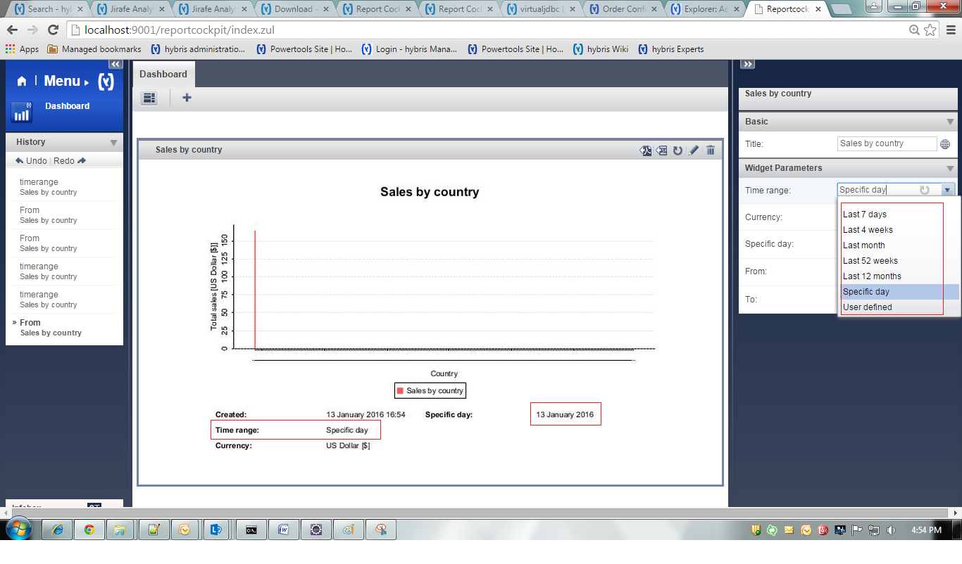

* 1. **Sales by hour :**

Displays overall sales by the hour over a 24 hours period.

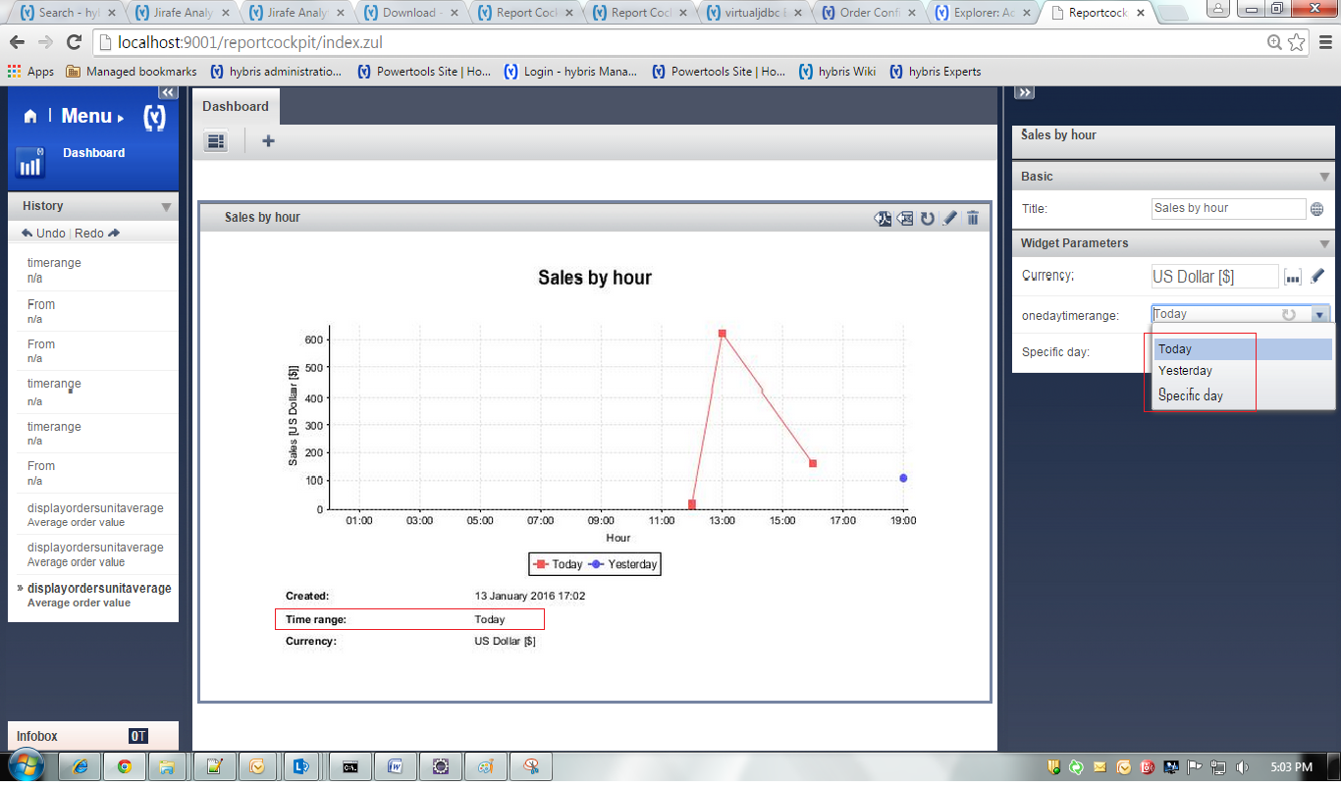

* 1. **Total sales :**

Displays total sales in a given time period

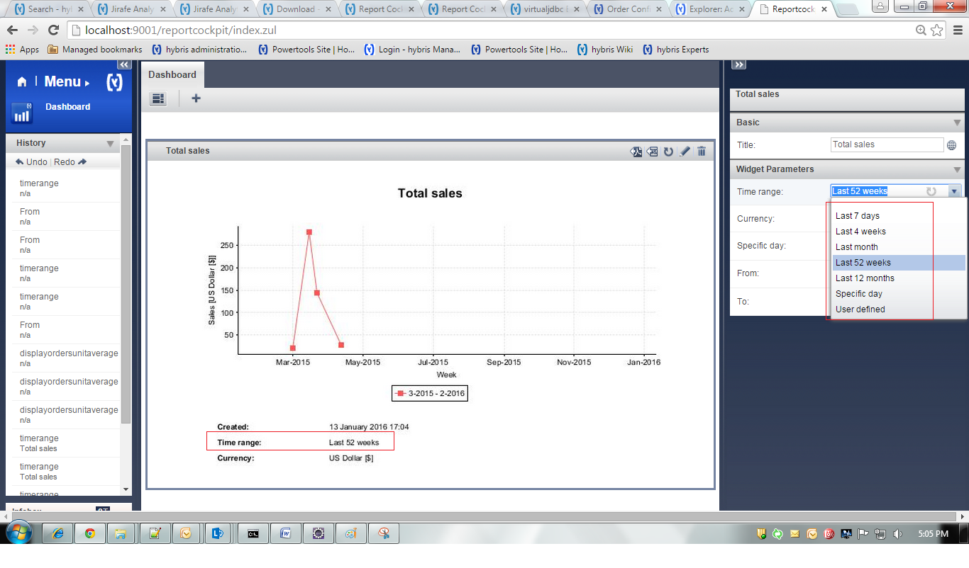

* 1. **Sales per Category :**

Displays Sales per category for given time frame.

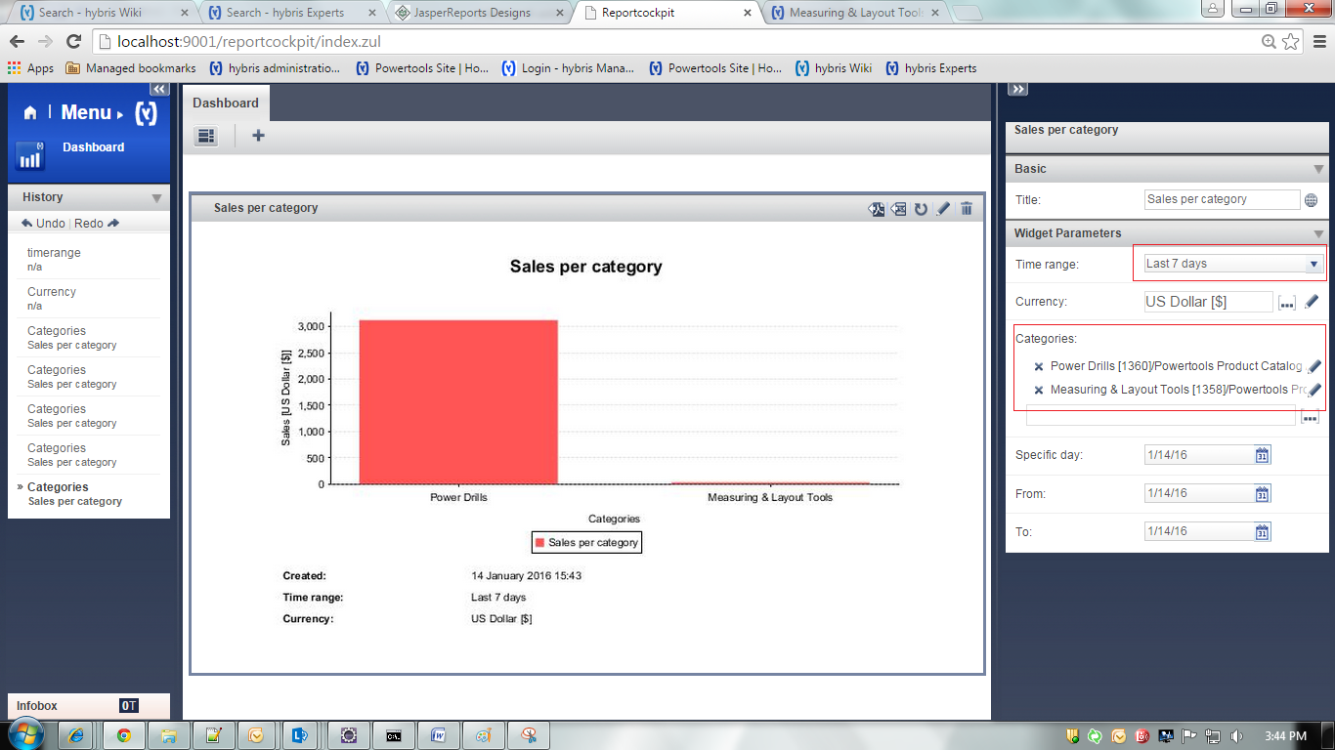

* 1. **Top selling products:**

Displays a list of the top 5 selling products across the system.

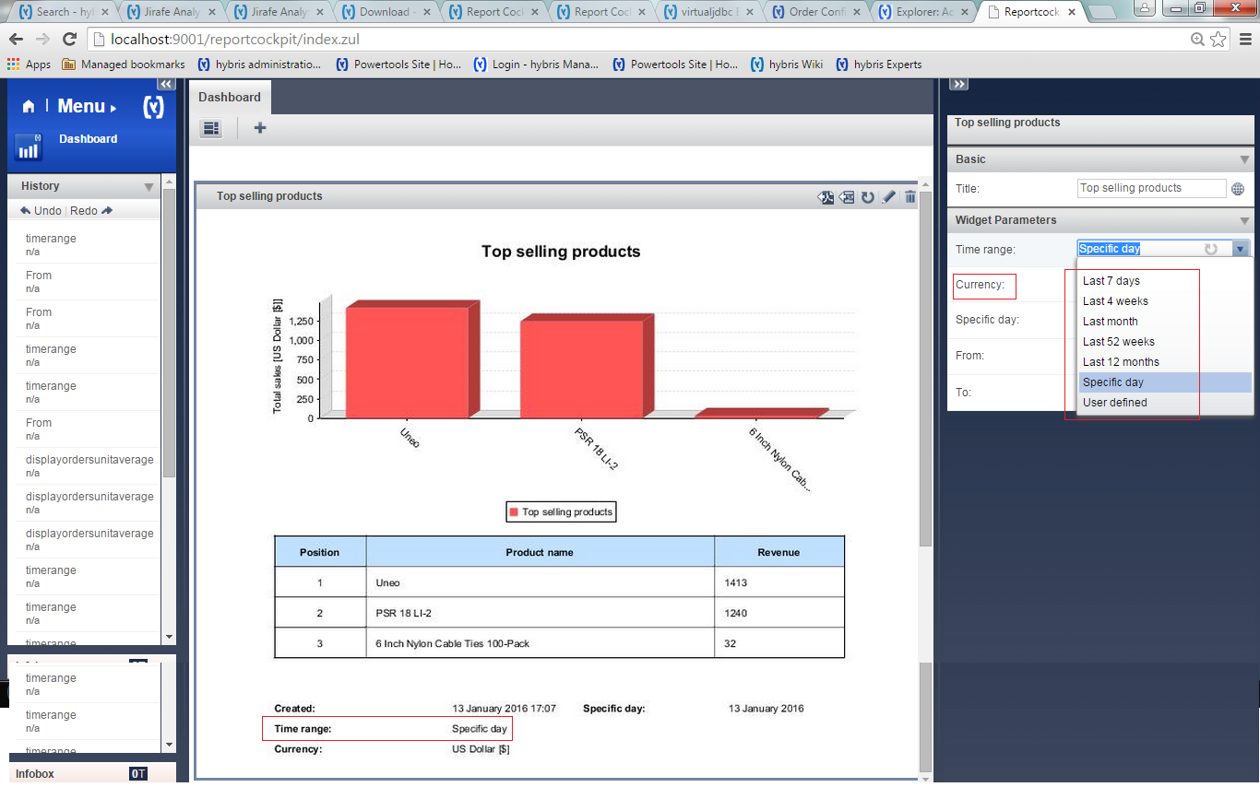

* 1. **Sales per Region :**

Displays sales for each region of Country

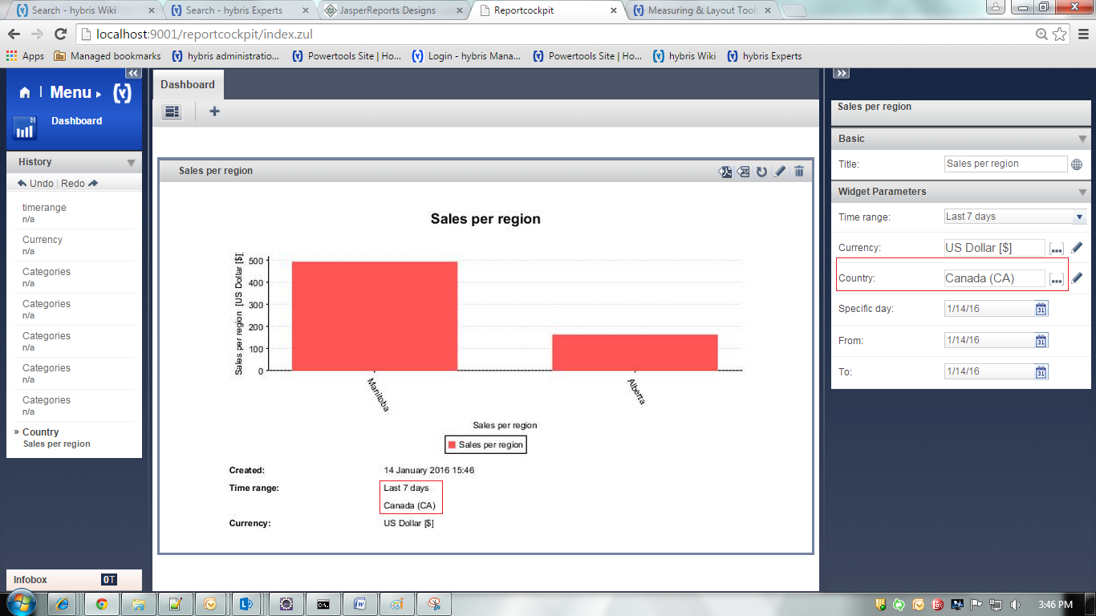

* 1. **Average Order Value By Site :**

Average order value for time range.

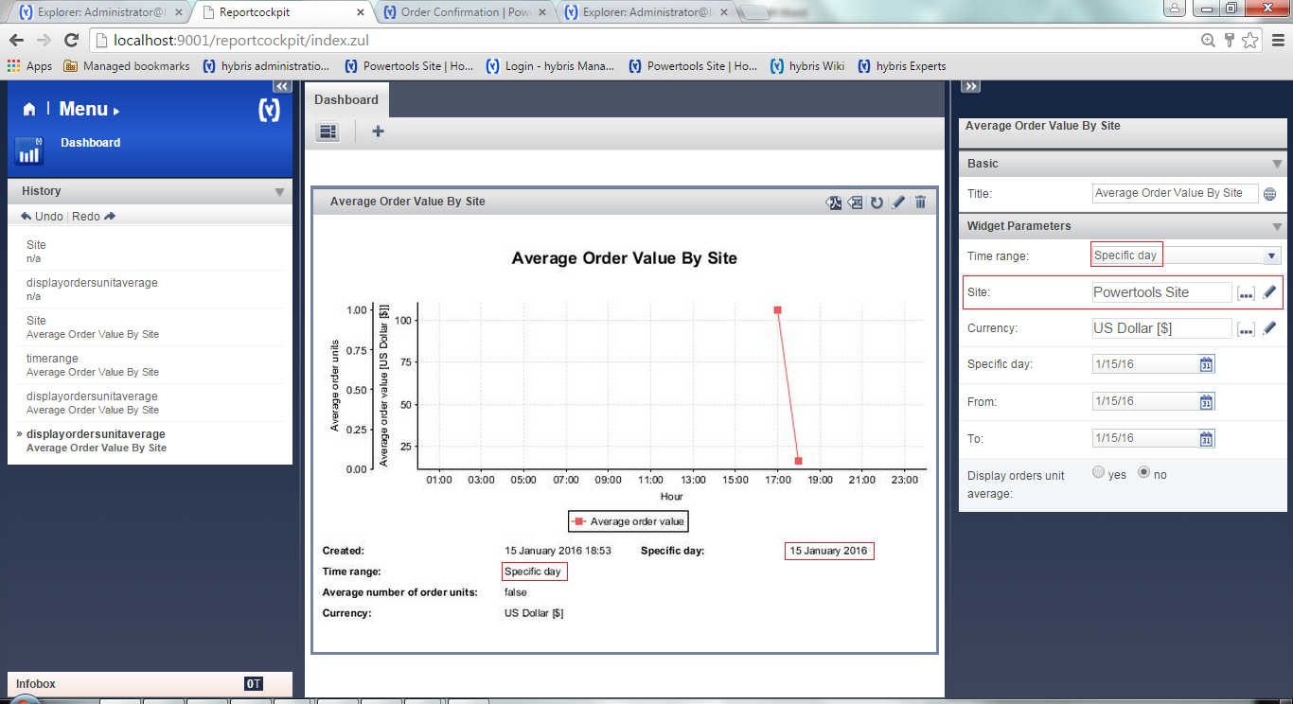

* 1. **Sales Per Region By Site:**

Displays sales for each region of Country (Site wise)

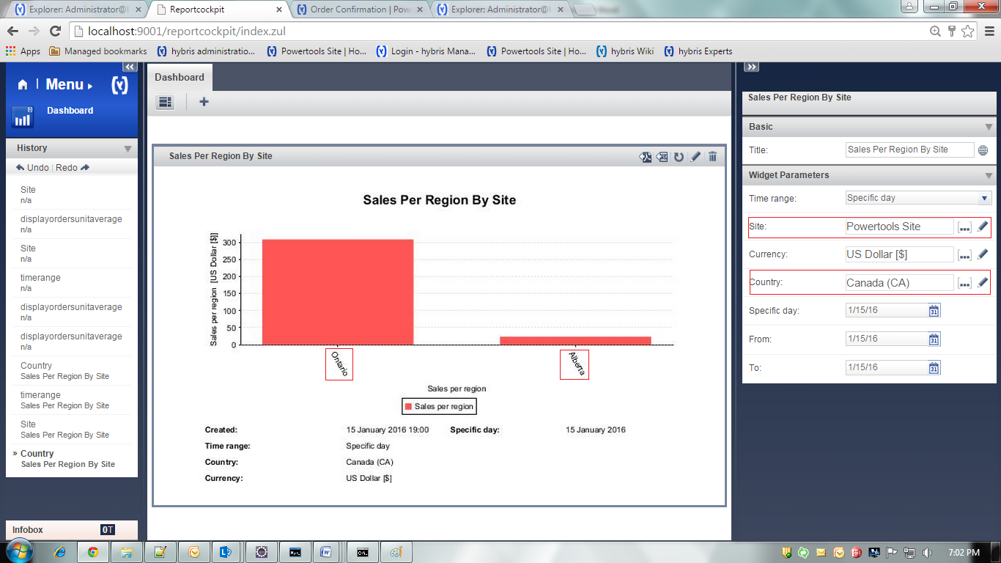

* 1. **Order Volume By Site:**

Displays how many orders have been placed over given time period. (Site wise)

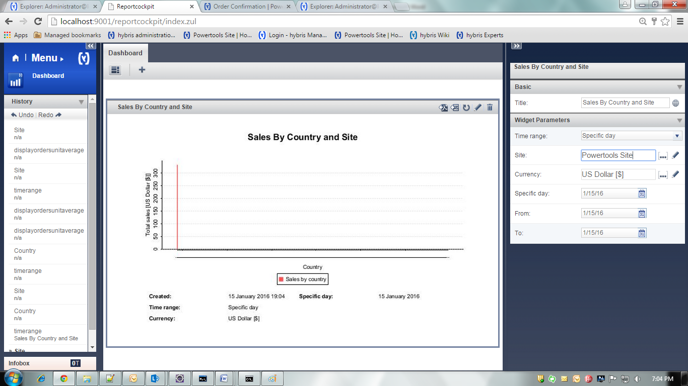

* 1. **Sales Per Category By Site:**

Shows sales per category for a given time frame. (Site wise)

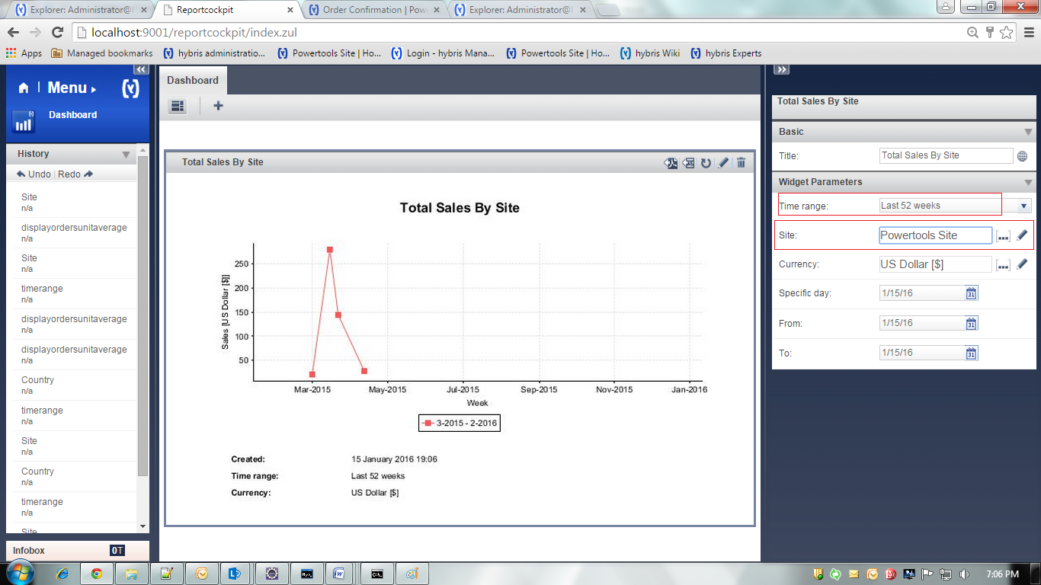

* 1. **Sales By Country and Site:**

Displays revenue by Country. (Site wise)

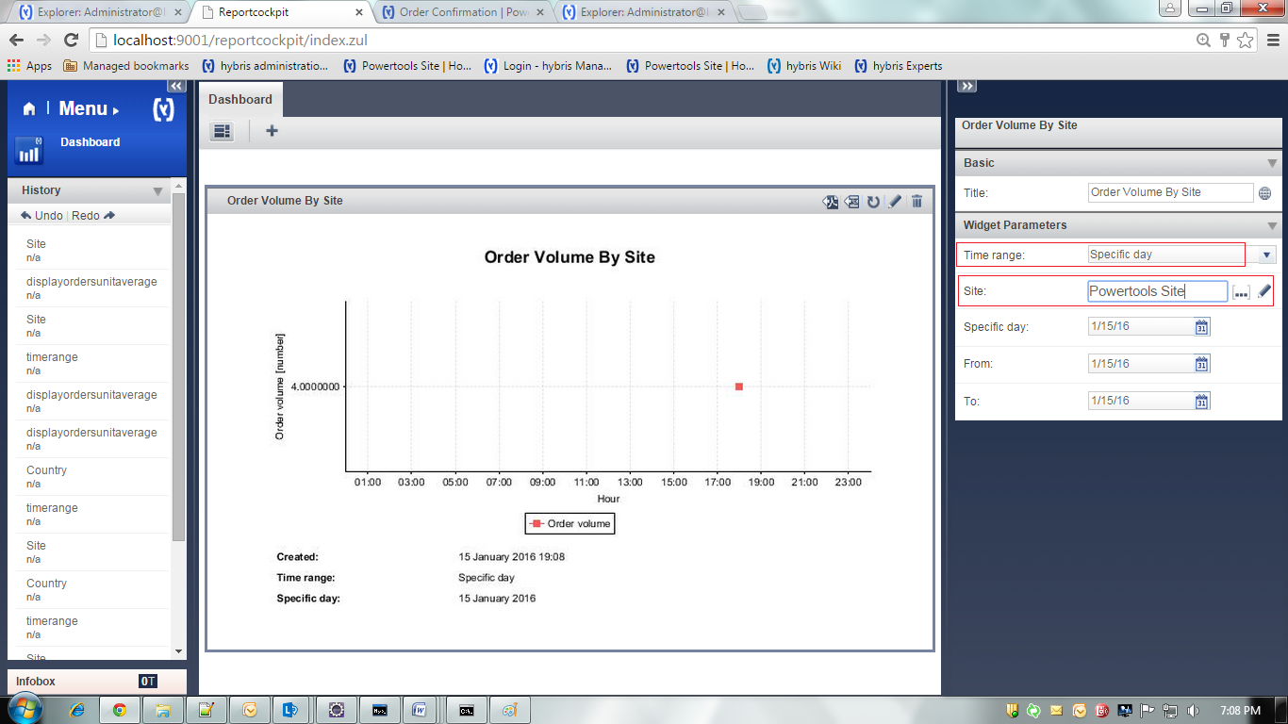

* 1. **Sales By hour and site:**

Displays overall Sales by Hour over a 24 hours period. (Site wise)

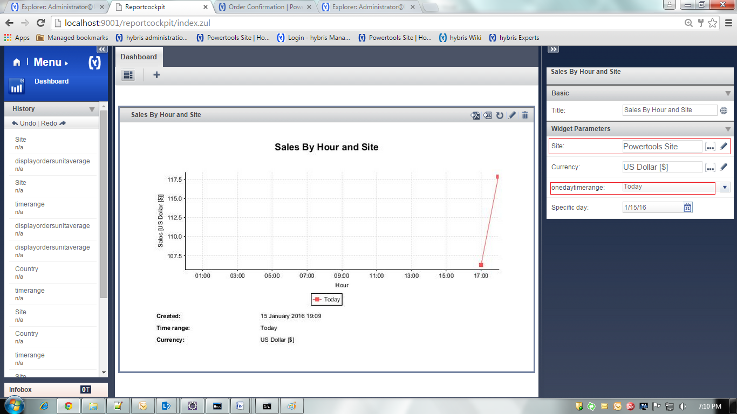

* 1. **Top Selling Products By Site:**

Displays a list of the top 5 selling products across the system. (Site wise)

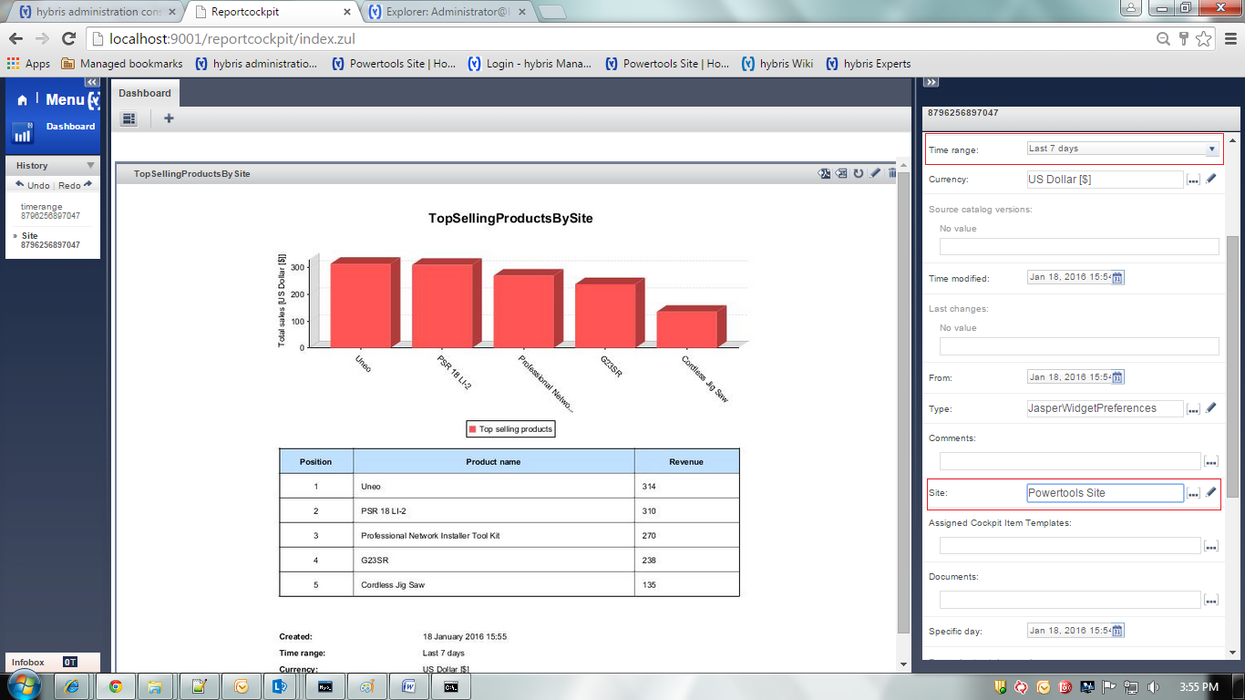

* 1. **Total sales By Site:**

Displays total sales in a given time period by site.

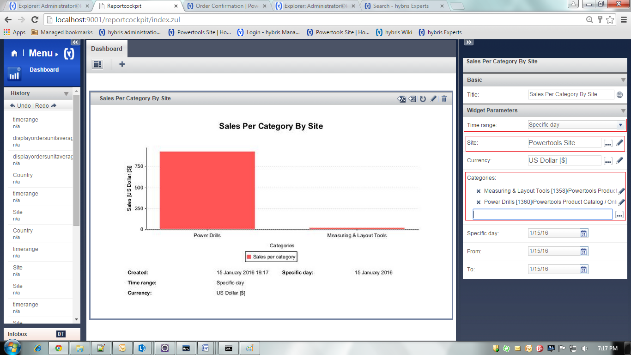

Download Reports

The hybris Report Cockpit enables you to download chosen reports to as Adobe Acrobat PDF or Microsoft Excel spreadsheet files. To download reports perform following steps:

1. Click one of the export icons from the top right-hand side of each Report widget: ReportCockpitFormatIcons.png.
2. Choose the download location and accept it.

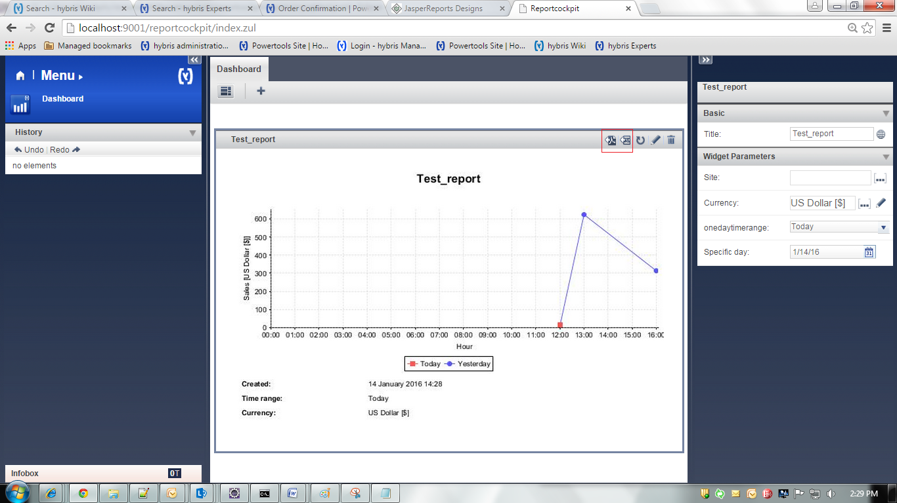

4. Reports in PDF & Excel.

|  |  |
| --- | --- |
|  |  |

Create Custom Reports (Jasper Reports)

This section provides information on how to create your own report\iReport file (.jrxml) and where to create.

1. Go to your eclipse where you have configured your site.
2. Go to -> **b2bassetscockpits\resources\b2bassetscockpits\reportcockpit\reports\mysql**

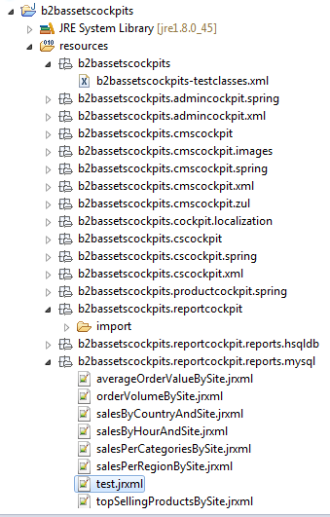

1. We are using MySql database, so we are going to create report file in...**\mysql** location
2. You can use location according to your database (i.e.  **...\hsqldb** or...**\oracle**).
3. Create file **Test.jrxml** at given location. [commented <!-- <field name="CODE" class="java.lang.String"/> --> in that file for CODE error]



1. You can add your own code in same <> tag format.
2. Upload the Test.jrxml file to the **Hybris Report Cockpit** as follows.

## Upload Custom Built Reports to the hybris Report Cockpit

1. Click the **Create new widget**.
2. The **Create new widget** window displays:



1. Select **Upload a new file**.
2. The **Create new widget - Upload file** window displays:
3. Provide the required information (**Identifier**, **Title**, **Description**).
4. Click the ReportCockpitGreenPlus.png and navigate to folder where you stored your **.jrxml** report file.
5. Click the **Done** icon.

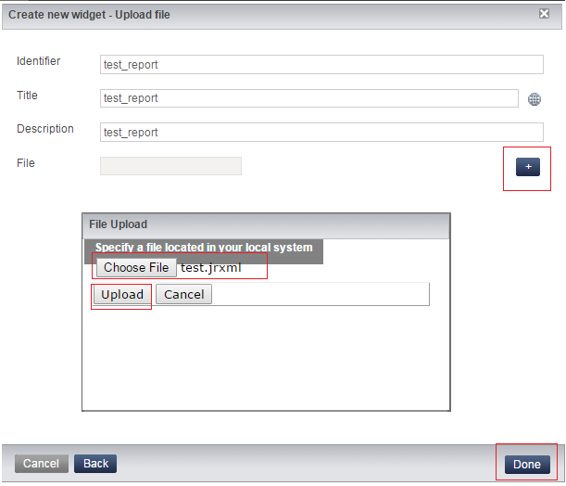

1. Your report is rendered in the **Dashboard**

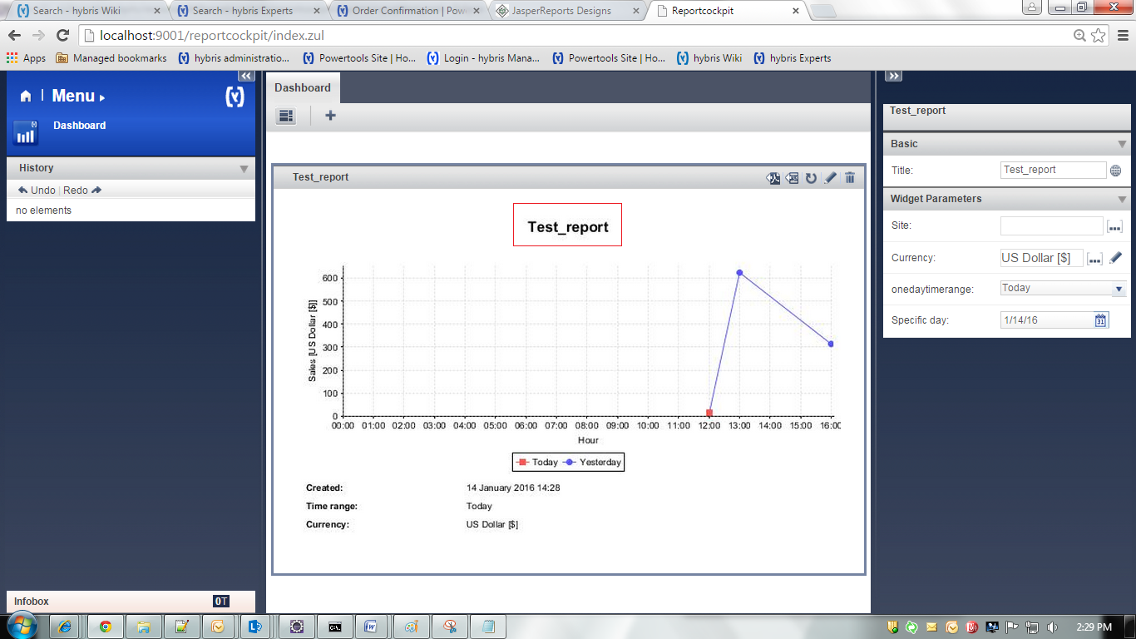

1. To delete custom report from existing media:

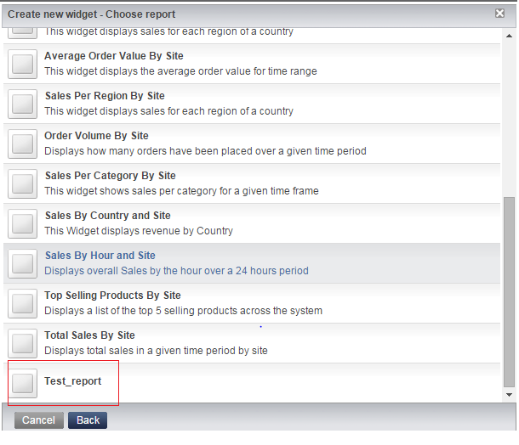

Go to HMC >Multimedia > Media> Search Folder: jasperreports > search > select your custom report > delete

